# Case Study: E-commerce Conversion Funnel Analysis

By: Nicolas Acha ([LinkedIn)](https://www.linkedin.com/in/nicoap/)

Deep dive into Conversion Funnel (CF) and looking to improve Conversion Rate (CR)

## Problem Statement:

The CEO requires a deep dive analysis of the CF to identify insights that could check whether the low CR is a general problem, or do we have something wrong at some stage in the funnel, particularly among new users. We have been provided with data from one day of operations to study the problem.

Once the insights are identified, we should offer strategies to improve the overall CR.

## Executive Insights:

In **Figure 1** we wanted to understand the General CR from each stage to understand the big picture in a typical day of operations.

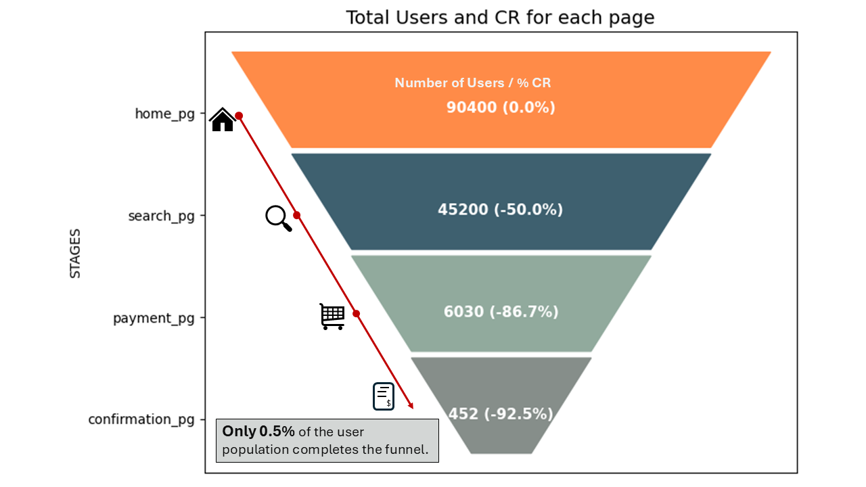

**Figure 1: General Conversion Rates (See Attachment 1 for granular detail)**

* *Half of the users abandoned the site without proceeding further to the home page*. The remaining half moved to the search page.
* *A significant drop occurred on the search page*, where *only 13% of users were willing to proceed to payment*.
* A *second significant drop* occurs when trying to confirm payment *where 92.5% of users abandoned their purchase*.
* In General, we can see that *only less than 1% of all visitors (0.5%) completed a purchase*.

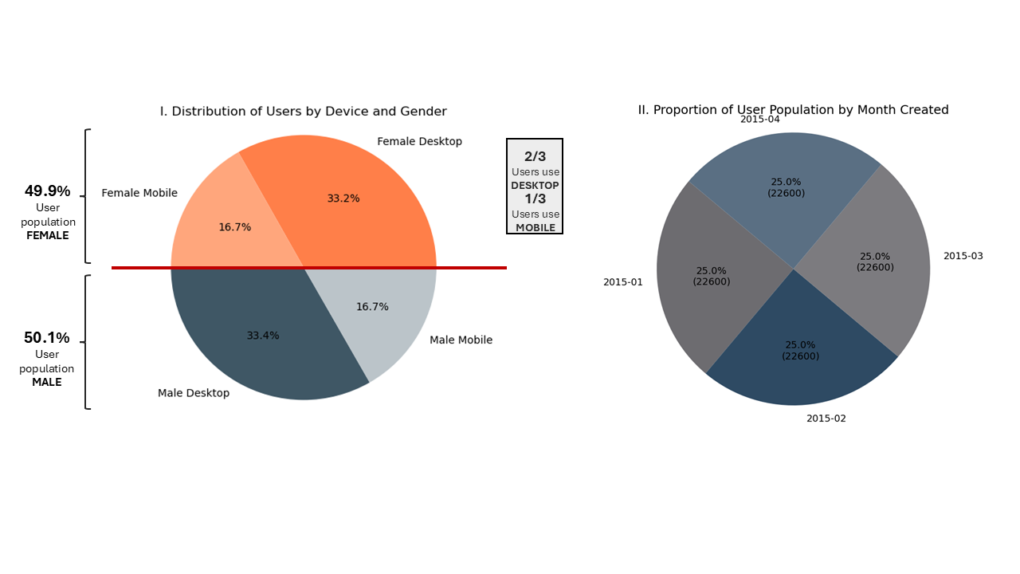

**Figure 2: Distribution of the User Population by Gender and Device**

**Figure 3: Users that end up making a purchase and its proportion based on gender and device**

* Looking at **Figure 3**, we can confirm the CEO's suspicion about new users. We observe that *users created after February 2015 experience a substantial reduction in their conversion rate*
* It was discarded that new users made fewer purchases because they represent a smaller proportion compared to older users. In Figure 2 one can clearly spot that *the number of users is exactly the same each month*
* **Figures 2 and 3** also indicate that when differentiating users by gender, the results are very symmetrical in each analysis. In this case, *there are no substantial differences between female and male users*
* On the other hand, grouping users by device reveals that the population of desktop users is twice as large as that of mobile users. However, *mobile users tend to confirm payments twice as often as desktop users*

***Table 1: Average Users Landing To each Page by Month.***

|  |  |  |  |  |  |
| --- | --- | --- | --- | --- | --- |
|  | *MONTH USERS CREATED AT* | *USERS IN HOME PG. PER DAY IN AVG* | *USERS IN SEARCH PG. PER DAY IN AVG* | *USERS IN PAYMENT PG. PER DAY IN AVG* | *USERS IN CONFIRM PAY PG. PER DAY IN AVG* |
| **OLD USERS** | **January** | 729 | 437 | 77 | 6 |
| **February** | 807 | 489 | 86 | 6 |
| **NEW USERS** | **March** | 729 | 286 | 20 | 1 |
| **April** | 753 | 303 | 20 | 2 |

* **Table 1** shows that we have consistently received a similar relative number of users each day, regardless of whether the users are old or new. The significant difference lies in the number of users who reach the search page
* There *appears to be an issue preventing new users from moving from the home page to the search page*.

***Table 2: Average Users Landing To each Page - Old vs. New Users.***

|  |  |  |  |  |
| --- | --- | --- | --- | --- |
|  | USERS IN HOME PG. PER DAY IN AVG | USERS IN SEARCH PG. PER DAY IN AVG | USERS IN PAYMENT PG. PER DAY IN AVG | USERS IN CONFIRM PAY PG. PER DAY IN AVG |
| **OLD USERS** | 766.1 | 461.7 | 81.4 | 6.1 |
| **% Conversion Rate** | **-40%** | **-82%** | **-92%** |
| **NEW USERS** | 741.0 | **294.4** | **20.1** | 1.5 |
| **% Conversion Rate** | **-60%** | **-93%** | **-93%** |

* **Table 2** reinforces the idea that new users have an issue with reaching the search page. New users are 20% more likely to abandon the site on the home page compared to older users. A similar pattern occurs at the payment stage, where new users are, on average, 10% more likely to abandon the site than older users

## Conclusions and Recommendations:

*Two identifiable issues seem to be contributing to the company’s low CR, particularly among users created after February 2015 (New Users)*

1. Users created after February 2015 have been constantly observed to have substantial higher drop out off rate in the stage home page to search page and in the search page to payment page transition.
2. In general, we have two massive drop off points in the funnel (At the Payment Page and the Confirmation Page) which require further efforts to reduce the abandonment rate.

*In my experience, this is a problem that requires the data analytics team and the business team to work in synergy. Where data helps to provide a diagnosis, while the business team comes up with strategies and the analytics team monitors the effects and progress of actions.*

In the short term, I recommend focusing all efforts on reversing the decline in conversion rates among new users. To address this issue, I would conduct further investigations to identify key differences between old and new users beyond just their creation date. This process would involve exploring questions such as:

*Do new users experience the same user journey as older users? Is there a specific reason why new users were created in recent months, different from the older ones? Does the company use the same pricing for both segments of users?*

Secondly and for midterm results I would recommend further investigation to understand why all types of users tend to abandon the site without selecting any products. Key questions to explore:

*Do we offer the right products? Is our pricing strategy aligned with our market segment? Why do 90% of users, who are generally willing to pay, fail to confirm their payments? Could this be related to the payment methods we offer?*

Finally, I would conduct a deep dive into mobile users to understand why they represent a minority of the user base but have a conversion rate twice as high as desktop users. Is this related to the user experience? Is the user profile significantly different between devices? What can we do to enhance the positive results seen with mobile users and replicate that success for desktop users?

## Analysis Approach:

In this case, the CEO needed a segmentation approach, so I chose to start by organizing data into larger groups, then progressively drilling down into smaller segments to uncover valuable insights.

But before that, I conducted data cleaning checks:

* Inspected for duplicated rows, missing values, or errors in each file
* Integrated all files into a single data frame, marking 1 if a user_id was present at a stage and 0 if not
* Checked that all rows made sense, ensuring, for example, that users appearing on the confirmation page were not missing from any of the previous stages

Then I started to study the funnel and segment the data by gender, device, and date, which allowed me to discard some assumptions, such as:

• There was no abnormal number of users by gender, device, or date of creation. The number of users in each dimension was consistent across all perspectives, e.g., the total number of old users was the same as the number of new users

Finally, I created some graphs and tabulations of the data to analyze drop off rates in each dimension. This analysis helped me identify key issues and provided hints about what actions can be taken to address the problems



You can access to the complete Jupiter notebook on this: [**LINK HERE**](https://github.com/NicoapBol/Data-Analytics-Projects/blob/main/007.%20Clara%20Data%20Case/00_case_code.ipynb)

## Attachments:

Attachment 1: Conversions Rates by Gender and Device

This Figure supports all the insights shown in the executive insights section. It shows that, regardless of gender or device, about half of the users drop off after the home page, with two major drop-offs at the payment and confirmation stages of the funnel.

We also notice that the total number of users and conversion rates are very symmetric across genders (very easy to spot when comparing graphs vertically). In contrast, when examining the numbers by device, we see that although mobile users make up only one-third of the population, they end up making twice as many purchases as desktop users (that can be see when comparing graphs horizontally).